1)Data Description and Processing

In the first step, normality of the variables are assessed through the shapiro.test and qqplot. The p-values on normality test for all the variables are less than alpha level equal to 0.05 and it could be concluded that the data is not normal. As discussed in the course slides, PCA assumes approximate normality of the input space distribution. Moving the data toward the normal distribution would lead to get more information. Therefore, log transformation has been used to normalize the data. Although this transformation could normalize couple of the variables but not all of them.

Applying more specific transformation without more details about the distribution of variables and their scales is not a wise decision. The figure 1 shows the normalization on total floor area of the building variable.

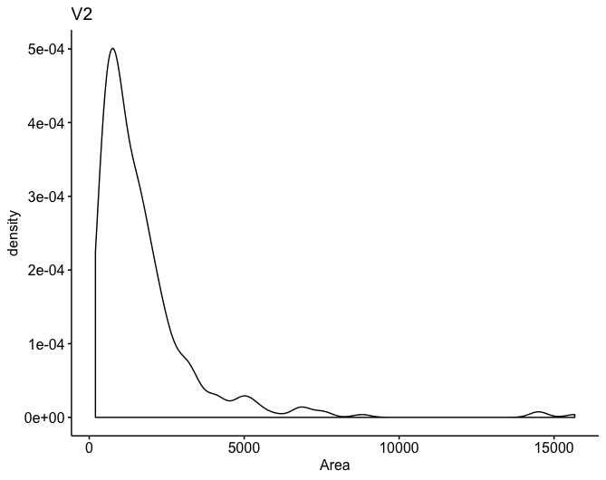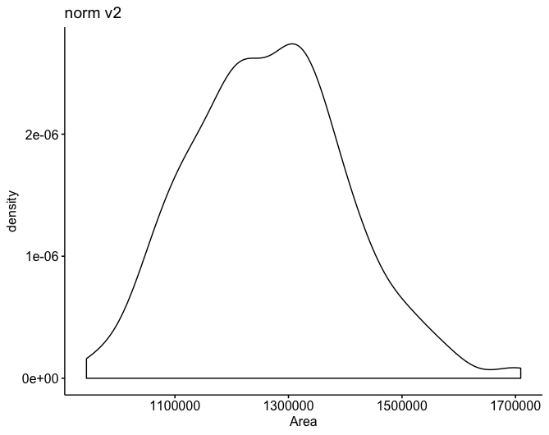

Figure 1

During this phase, the output variables are separated to make the data ready for PCA investigation.

2)PCA Analysis

PCA analysis could be done using both covariance and correlation. The main reason that correlation matrix has been selected for principal component analysis is that the variables have different scales and needs to be standardized. According to the figure 2, biplot shows outliers and principal component directions.

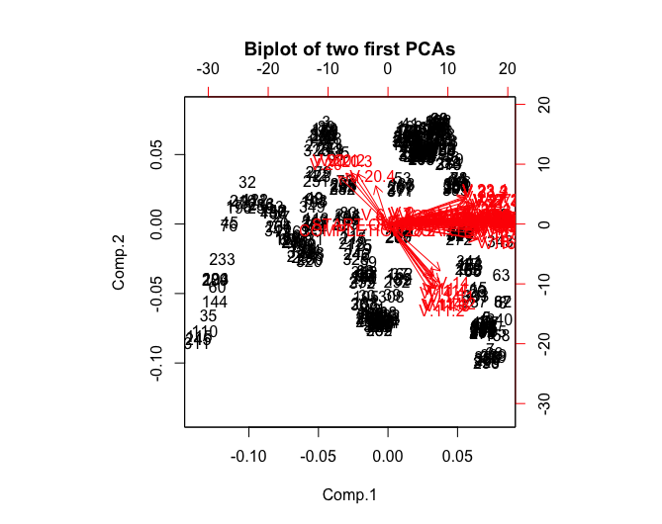

Figure 2

Interpretation of Biplot

|  |  |  |  |  |  |  |  |  |  |  |  |
| --- | --- | --- | --- | --- | --- | --- | --- | --- | --- | --- | --- |
| Name | 1 | 2 | 3 | 4 | 5 | 6 | 7 | 8 | 9 | 10 | 11 |
| St. Dev | 8.59 | 2.53 | 2.16 | 2.11 | 1.88 | 1.72 | 1.31 | 1.29 | 1.13 | 1.08 | 0.96 |
| Prop. Var | 0.69 | 0.06 | 0.043 | 0.04 | 0.03 | 0.03 | 0.016 | 0.015 | 0.015 | 0.011 | 0.008 |
| Cum. Var | 0.69 | 0.75 | 0.79 | 0.83 | 0.87 | 0.89 | 0.91 | 0.93 | 0.94 | 0.95 | 0.96 |

Table 1

To decide about the number of PCAs we need to use, we need to account that how much information regarding the variance would be acquired by selecting each component. As it is shown in table 1, the first component contributes around 65% of variance. By increasing the number of components, the cumulative variance would also increase. One possible solution would be to consider all the above eleven components to reach 96% variance of the data. However, this is not the optimal case. We need to consider that from component 7, they are contributing to less than 10% of variance. On the other side, increasing the number of components would lead to more coefficients in the regression problem and make the linear model more complex. The complex model could lead to overfitting problems. Therefore, first 7 components are considered to build the regression model.

Aside from summary of principal components summarized in the table 1, scree plot of first 10 components show the trend of variance. This plot confirms that by considering the first 7 components we should be able to form a solid baseline to build the regression model on top of that.

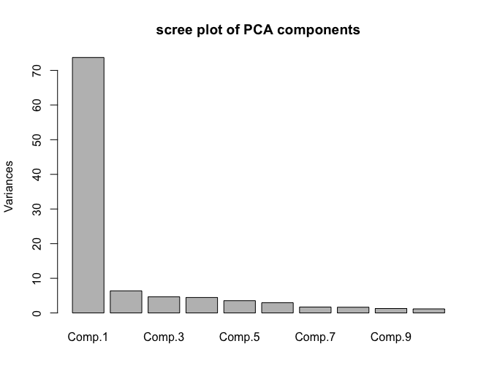

Figure 3

According to figure 2, many of the variables are lying toward the same components. The biplot shows scores and loadings of the variables on the first two principal components. As we utilized the correlation matrix the standard deviation of the vectors is equal to 1. The plot suggested that most of the data points (observations) could be explained by using two components. The arrows in the left upper part of the plot could be observation which might be outliers. As number of the observations are high, the loadings of the seven first components we picked would be shown in the appendix Table 2). The loadings show that the PCAs we picked is able to maximize the information we need through the data.

3)PC based Regression Analysis

In this section, the linear regression defined for the analysis is explained. As discussed in the previous section, seven principal components could help to maximize the information gathered from data. Therefore, all the components would be used in the regression analysis. However, it was taken to an account if it leads to overfitting or not. If it would have led to overfitting, the smaller number of components would have been selected to make the model less complex. The result for linear regression model has been shown in following table:

Table 2

|  |  |  |  |
| --- | --- | --- | --- |
| R-Squared | 0.59 | P-Value | < 2.2e-16 |

As number of the coefficients is more than two, the Actual and predicted results of the linear model plotted in Figure 4 to get a better sense about the model’s performance.

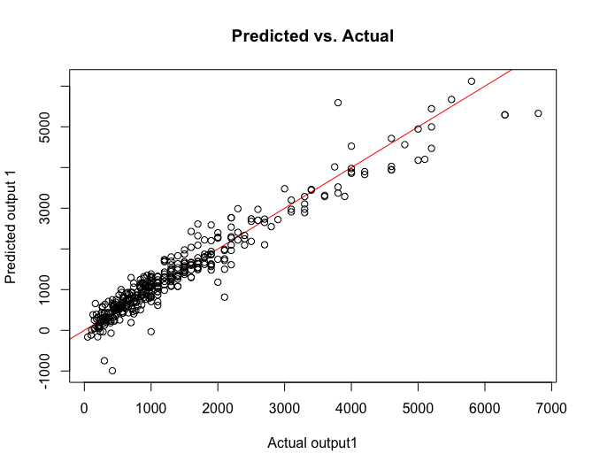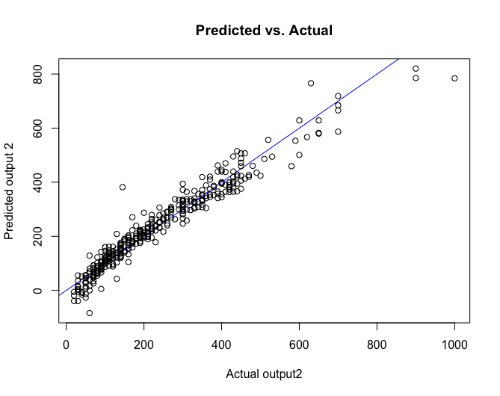

Figure 4

Provide statistics for your regression model: R^2, significance of regression coefficients

Output 2: R^2 = 0.75, p-value < 2.2e-16

References:

1. Flury, B., 2013. A first course in multivariate statistics. Springer Science & Business Media.

Table 2: PCA loadings for the variables across the first seven components

|  |  |  |  |  |  |  |  |
| --- | --- | --- | --- | --- | --- | --- | --- |
|  | Comp.1 | Comp.2 | Comp.3 | Comp.4 | Comp.5 | Comp.6 | Comp.7 |
| START.YEAR | 0.11572182 | 0.01743102 | -0.0024579 | -0.0170006 | -0.0084997 | 0.03161366 | 0.01135205 |
| START.QUARTER | -0.0092236 | -0.0024339 | 0.31391347 | 0.15133566 | 0.14748061 | -0.3146144 | -0.1331871 |
| COMPLETION.YEAR | 0.11483457 | 0.02192261 | 0.00658437 | -0.0041661 | 0.0093082 | 0.00185726 | 0.01894984 |
| COMPLETION.QUARTER | 0.004377 | -0.023622 | -0.040344 | -0.0656829 | -0.0659011 | 0.13387173 | 0.0511578 |
| V.1 | 0.00658289 | -0.0059371 | 0.05425808 | 0.01457606 | 0.36224053 | 0.23715341 | -0.088659 |
| V.2 | 0.01456697 | 0.04008975 | -0.0315616 | -0.0152175 | -0.3780452 | -0.2494822 | -0.0660159 |
| V.3 | 0.01219846 | 0.03232798 | -0.02408 | -0.024837 | -0.3759203 | -0.242084 | -0.0775921 |
| V.4 | 0.07348901 | 0.04563938 | -0.0294408 | -0.0107666 | -0.3422349 | -0.2079196 | -0.0157433 |
| V.5 | 0.10026541 | 0.03209461 | -0.0151623 | -0.0019726 | -0.1654098 | -0.0812401 | 0.0396547 |
| V.6 | -0.014959 | 0.03146274 | -0.0775052 | 0.04826113 | -0.3444593 | -0.1492468 | 0.12151071 |
| V.7 | 0.01198049 | 0.03547655 | -0.0641805 | 0.03146575 | 0.04153546 | 0.03830118 | 0.18850614 |
| V.8 | 0.09332762 | 0.0195436 | -0.0264514 | 0.02654923 | -0.1915961 | -0.1039507 | 0.05513952 |
| V.11 | 0.05616656 | -0.2270181 | -0.0962222 | 0.17112135 | -0.0160679 | 0.04992228 | -0.0412567 |
| V.12 | 0.11567168 | 0.01262231 | 0.02413711 | -0.0339336 | 0.0095522 | -0.0056369 | -0.0157228 |
| V.13 | 0.11584817 | 0.01422513 | 0.01554548 | 0.00662278 | 0.0063083 | 0.00250191 | -0.0158225 |
| V.14 | 0.06577919 | -0.200409 | -0.1126104 | 0.11985946 | -0.0149734 | 0.02525174 | -0.0418373 |
| V.15 | 0.11570736 | 0.01196531 | 0.01561088 | -0.0307343 | 0.00709359 | 0.00432844 | -0.0008922 |
| V.16 | 0.11265683 | -0.0654096 | 0.02330774 | 0.03313917 | 0.00828021 | -0.0161641 | -0.0037117 |
| V.17 | 0.11501383 | -0.0291096 | 0.02856531 | -0.0467699 | 0.00218581 | 0.00526209 | 0.00061086 |
| V.18 | 0.06659321 | 0.03546884 | -0.3101392 | -0.0454252 | 0.13761495 | -0.1379389 | 0.03761094 |
| V.19 | 0.10711083 | 0.03352792 | -0.1315635 | -0.0193281 | 0.06581219 | -0.070555 | -0.0199916 |
| V.20 | -0.0623864 | 0.20637272 | -0.1192028 | 0.2086431 | 0.00037067 | 0.01597559 | 0.07306644 |
| V.21 | 0.11439935 | 0.01481183 | 0.01830133 | -0.0258679 | 0.00981868 | 0.00070235 | -0.01439 |
| V.22 | 0.11431776 | 0.00512291 | 0.02443399 | -0.0477675 | 0.01286378 | -0.0095255 | -0.025995 |
| V.23 | 0.09866485 | 0.06536198 | 0.07319527 | -0.0855826 | 0.00456575 | 0.03949223 | 0.09925039 |
| V.24 | 0.10058195 | 0.06582636 | -0.0528922 | 0.17205218 | -0.0059022 | 0.03280195 | -0.0559371 |
| V.25 | 0.11593571 | 0.02346077 | 0.00061997 | 0.02188292 | 0.00068678 | 0.01367362 | -0.0114761 |
| V.26 | 0.11602352 | 0.01906941 | 0.00285502 | 0.01118407 | 0.0042787 | 0.00869789 | 0.00237659 |
| V.27 | 0.10820654 | 0.08405236 | 0.00166337 | 0.03682743 | 0.01236567 | 0.02752126 | 0.06094237 |
| V.28 | 0.03334614 | 0.02805481 | -0.3639228 | -0.1266374 | 0.16660408 | -0.1956311 | 0.0626303 |
| V.29 | 0.11263667 | 0.02176712 | 0.01712232 | -0.0622125 | 0.00022213 | 0.00658527 | -0.0414312 |
| V.11.1 | 0.05677527 | -0.276562 | -0.008824 | 0.15526579 | -0.0093136 | -0.0043386 | -0.0757669 |
| V.12.1 | 0.11577888 | 0.01438414 | 0.01595877 | -0.0313266 | 0.01000431 | -0.0063913 | -0.0162729 |
| V.13.1 | 0.11578558 | 0.01858186 | -0.0006119 | 0.01289039 | 0.01107458 | -0.006376 | -0.0121916 |
| V.14.1 | 0.06391738 | -0.2489834 | -0.0042017 | 0.14635188 | -0.0230558 | 0.00608123 | -0.1411285 |
| V.15.1 | 0.11571925 | 0.01011071 | 0.02470137 | -0.02937 | 0.00438249 | 0.00637892 | -0.0099599 |
| V.16.1 | 0.11268192 | -0.0626382 | -0.0152597 | 0.00561294 | 0.01704112 | -0.0139287 | 0.02088954 |
| V.17.1 | 0.11522031 | -0.019123 | 0.02380699 | -0.0464215 | 0.00552526 | -0.0029375 | 0.01352928 |
| V.18.1 | 0.06643931 | 0.02088345 | -0.0748966 | -0.0329403 | -0.165806 | 0.30813774 | -0.3147754 |
| V.19.1 | 0.10748357 | 0.01094137 | -0.0276208 | -0.0162194 | -0.0670969 | 0.12975417 | -0.1761468 |
| V.20.1 | -0.0527643 | 0.2185878 | -0.0972082 | 0.26326206 | -0.0207192 | 0.07444775 | 0.00332973 |
| V.21.1 | 0.1143849 | 0.01560418 | 0.01430177 | -0.0265805 | 0.00713478 | 0.0035476 | -0.0309209 |
| V.22.1 | 0.11436505 | 0.00492425 | 0.01614408 | -0.0478806 | 0.00817416 | -0.003713 | -0.0108699 |
| V.23.1 | 0.09852308 | 0.09470467 | 0.06457877 | -0.1246392 | 0.02726312 | 0.00393168 | 0.11486956 |
| V.24.1 | 0.10120376 | 0.05533232 | -0.0592047 | 0.17957431 | -0.000363 | 0.028168 | -0.0457468 |
| V.25.1 | 0.11584731 | 0.02482337 | 0.00271467 | 0.03016336 | 0.00445228 | 0.00859081 | -0.0055724 |
| V.26.1 | 0.11589315 | 0.02124488 | 0.00510349 | 0.01268402 | 0.0016823 | 0.01325107 | 0.00319196 |
| V.27.1 | 0.10870847 | 0.0856592 | -0.0046259 | 0.02909483 | 0.01781178 | 0.0186529 | 0.05937469 |
| V.28.1 | 0.02588359 | -9.55E-05 | -0.0806706 | -0.1150138 | -0.2210534 | 0.36725912 | -0.3679791 |
| V.29.1 | 0.11300221 | 0.02119002 | 0.03298181 | -0.0326955 | 0.00775893 | -0.0020903 | -0.0383458 |
| V.11.2 | 0.05427926 | -0.2951919 | -0.0763325 | 0.10901946 | 0.0328249 | -0.0453264 | 0.05425643 |
| V.12.2 | 0.11581334 | 0.01517278 | 0.01521177 | -0.0262002 | 0.00554448 | 0.0002967 | -0.0201377 |
| V.13.2 | 0.11549203 | 0.02184589 | -0.0106545 | 0.02165077 | 0.00415686 | 0.00318996 | -0.0242408 |
| V.14.2 | 0.06559708 | -0.2720693 | -0.0745428 | 0.0855657 | 0.02806254 | -0.052911 | 0.07967819 |
| V.15.2 | 0.11582327 | 0.00965606 | 0.02126623 | -0.0296658 | 0.00774265 | 0.00170513 | 0.00255181 |
| V.16.2 | 0.11261755 | -0.0403386 | -0.0014694 | 0.00457932 | 0.00073274 | 0.01598722 | 0.01314023 |
| V.17.2 | 0.11524982 | -0.00917 | 0.02296493 | -0.0438663 | 0.00396711 | -0.0046631 | 0.01110466 |
| V.18.2 | 0.06892246 | 0.00869227 | 0.1323886 | 0.13619117 | -0.0786957 | 0.16812432 | 0.31901431 |
| V.19.2 | 0.10879288 | -0.0036274 | 0.06034481 | 0.05589618 | -0.0324353 | 0.07019035 | 0.09999892 |
| V.20.2 | -0.0461481 | 0.2200137 | -0.0799506 | 0.29907909 | -0.0096547 | 0.04754606 | 0.04289034 |
| V.21.2 | 0.11414282 | 0.01420772 | 0.01571259 | -0.0140869 | 0.00593406 | 0.00196199 | 0.00025121 |
| V.22.2 | 0.1145524 | 0.01534641 | 0.02905085 | -0.036285 | 0.00981791 | -0.0064169 | -0.0124705 |
| V.23.2 | 0.09837832 | 0.10954656 | 0.06184039 | -0.1445358 | 0.02024399 | 0.01314239 | 0.07473336 |
| V.24.2 | 0.10136443 | 0.04537361 | -0.0654543 | 0.18525604 | 0.00560699 | 0.02633246 | -0.059319 |
| V.25.2 | 0.11573909 | 0.02686204 | -0.0029376 | 0.0339351 | 0.00872029 | 0.00421614 | -0.0108771 |
| V.26.2 | 0.11571229 | 0.02467673 | 0.00789814 | 0.01583897 | 0.00213714 | 0.01206198 | 0.00622774 |
| V.27.2 | 0.10910125 | 0.08353394 | 2.34E-05 | 0.01778821 | 0.01424077 | 0.02078843 | 0.04571667 |
| V.28.2 | 0.02521865 | -0.0204993 | 0.1965521 | 0.11270485 | -0.1236449 | 0.19347445 | 0.48991336 |
| V.29.2 | 0.11308722 | 0.01903412 | 0.01840462 | -0.0187967 | 0.02275578 | -0.0228185 | -0.0536603 |
| V.11.3 | 0.05780457 | -0.2751037 | -0.0355981 | 0.06316847 | -0.0406788 | 0.02888204 | -0.0096999 |
| V.12.3 | 0.11581814 | 0.01687513 | 0.01689063 | -0.016406 | 0.00399473 | 0.00083305 | -0.0143768 |
| V.13.3 | 0.11500262 | 0.02645494 | -0.0131892 | 0.03661667 | 0.00050689 | 0.00932244 | -0.0125342 |
| V.14.3 | 0.05963034 | -0.2773618 | -0.018688 | 0.08031573 | -0.0108189 | -0.0043728 | -0.0369615 |
| V.15.3 | 0.11584482 | 0.00971228 | 0.02294689 | -0.0299963 | 0.00707852 | 0.00095499 | -0.0126881 |
| V.16.3 | 0.11231114 | -0.0242494 | 0.00849672 | 0.01301949 | -0.0087129 | 0.0241297 | 0.06824282 |
| V.17.3 | 0.1152452 | 0.00331391 | 0.01759384 | -0.0419135 | 0.003014 | -0.0025478 | 0.02327248 |
| V.18.3 | 0.06278478 | 0.01612478 | 0.23956769 | 0.17354209 | 0.11864734 | -0.2162355 | -0.1277587 |
| V.19.3 | 0.10669054 | -0.0075844 | 0.11498332 | 0.07483193 | 0.04786235 | -0.0944753 | -0.0819559 |
| V.20.3 | -0.0383449 | 0.2161012 | -0.0807411 | 0.31684315 | 0.00856152 | 0.01248673 | -0.0108069 |
| V.21.3 | 0.11407286 | 0.01245904 | 0.02193353 | -0.0158284 | -0.0035215 | -0.0070345 | -0.0259378 |
| V.22.3 | 0.11439417 | 0.01516077 | 0.0183923 | -0.0228827 | 0.0109753 | -0.0167844 | -0.009916 |
| V.23.3 | 0.09841453 | 0.1127458 | 0.06324208 | -0.1467744 | 0.01557722 | 0.0188571 | 0.08003967 |
| V.24.3 | 0.10186038 | 0.03386281 | -0.0749524 | 0.18585871 | -0.0078683 | 0.03071586 | -0.038035 |
| V.25.3 | 0.11564612 | 0.02748277 | -0.0106304 | 0.03515773 | 0.00399646 | 0.01071634 | -0.0095877 |
| V.26.3 | 0.11557044 | 0.02699647 | 0.00681336 | 0.01714263 | 0.00273307 | 0.00968676 | 0.00393387 |
| V.27.3 | 0.10943033 | 0.08211397 | 0.00758268 | 0.01211195 | 0.00960025 | 0.01670772 | 0.05517371 |
| V.28.3 | 0.01584785 | 0.0010869 | 0.31464677 | 0.14935081 | 0.14625455 | -0.3091337 | -0.1309475 |
| V.29.3 | 0.11308596 | 0.01031102 | -0.0071249 | -0.0207707 | 0.01441898 | -0.0121291 | -0.0619289 |
| V.11.4 | 0.05759543 | -0.2213758 | -0.0426916 | 0.05098498 | -0.0448461 | 0.03179782 | 0.19761327 |
| V.12.4 | 0.11576697 | 0.01775753 | 0.01713225 | -0.0089568 | 0.00608727 | -0.0034265 | -0.0195256 |
| V.13.4 | 0.11419701 | 0.03050516 | -0.0094806 | 0.05454829 | 0.00383668 | 0.00045422 | -0.0163965 |
| V.14.4 | 0.05495736 | -0.235202 | -0.0816779 | 0.04139882 | -0.0267368 | 0.01065374 | 0.23523571 |
| V.15.4 | 0.11591416 | 0.01078769 | 0.01554679 | -0.0317558 | 0.00635671 | 0.00422108 | -0.0018311 |
| V.16.4 | 0.11130616 | -0.0037743 | 0.02444796 | 0.01576104 | 0.0079829 | -0.0079335 | 0.05915015 |
| V.17.4 | 0.11522173 | 0.01867027 | 0.02252056 | -0.0329904 | 0.00285728 | -0.0001931 | 0.01939382 |
| V.18.4 | 0.07346233 | 0.02929135 | -0.2918402 | -0.043892 | 0.1345766 | -0.1226909 | 0.03167653 |
| V.19.4 | 0.10886737 | -0.0114237 | -0.123056 | -0.0260098 | 0.06511596 | -0.0617272 | -0.0084509 |
| V.20.4 | -0.0155432 | 0.16423559 | -0.1564989 | 0.3122443 | 0.02611556 | 0.03416547 | -0.0427178 |
| V.21.4 | 0.11366832 | 0.00812476 | 0.01422748 | -0.0159741 | 0.01154653 | -0.0012819 | -0.0121683 |
| V.22.4 | 0.11448817 | 0.02592044 | 0.00661101 | -0.0210492 | 0.00981483 | -0.0098881 | -0.0278923 |
| V.23.4 | 0.09796302 | 0.11865241 | 0.07874258 | -0.1438101 | 0.0131576 | 0.00884813 | 0.05989978 |
| V.24.4 | 0.10258946 | 0.02233288 | -0.0606033 | 0.18965989 | -0.0096587 | 0.03619504 | -0.0358769 |
| V.25.4 | 0.11556385 | 0.02479125 | -0.0052482 | 0.03938752 | -9.33E-05 | 0.01686292 | -0.0074751 |
| V.26.4 | 0.11552946 | 0.0268805 | 0.00372811 | 0.01483005 | 0.00196187 | 0.01180804 | 0.00101718 |
| V.27.4 | 0.10966165 | 0.07612992 | 0.02046451 | 0.00236634 | 0.00960195 | 0.01117007 | 0.04348226 |
| V.28.4 | 0.03363712 | 0.02852479 | -0.3634798 | -0.1267374 | 0.16648078 | -0.1954956 | 0.06302819 |
| V.29.4 | 0.11346105 | -0.0004014 | -0.0002477 | -0.0064776 | -0.0021436 | 0.00683942 | -0.048311 |